 | Department of Electrical Engineering and Mechatronics  Vehicles and Mechatronics Institute  Faculty of Engineering  University of Debrecen

Thesis

Thesis title

by NAME
BSc / MSc / postgraduate program name

Debrecen
Year

On this page, the task assignment will be prepared, signed, and stamped by the department (in PDF or image format). Or (when printing), the original assignment sheet must be replaced with this page.
On this page, there will be the thesis declaration signed by the student (in PDF or image format). Or (when printing), the declaration in Word format, which we kindly ask you not to forget to sign. The declaration is available here https://eng.unideb.hu/sites/default/files/inline-files/Appendix3_thesis_declaration_1.docx

If the thesis is classified, the classification request and confidentiality agreement follow the thesis declaration. The agreement is available here https://eng.unideb.hu/sites/default/files/appendix2_confidentiality_agreement_0.docx
Abstract
This page must contain a maximum 1-page abstract. This is a mandatory element. The abstract must include the thesis's purpose, the solved subtasks, the methods used, the results of the work, the work's applicability and usability, and the conclusion of the topic.
The content of the abstract should resemble the introduction and summary chapters of the thesis, but it must be structured in such a way that reading this single page alone gives anyone a complete picture of the thesis.

Absztrakt
The Hungarian-language version of the English-language abstract on the previous page does not necessarily have to be the student's independent work; assistance from a language teacher or translator may be used for the translation. Mandatory element.

Table of Contents
This page must contain the table of contents.
Guide: https://www.youtube.com/watch?v=vfAdcbOUc0Q
Example table of contents:
Table of Contents
Table of Contents 1
List of Abbreviations 2
List of Tables 3
List of Figures 4
Introduction 5
1 Individual chapter titles must be numbered; the text style for main chapters is Heading 1. Every main chapter must start on a new page. 5
1.1 The style for first-level subchapters is Heading 2. 5
1.1.1 The style for second-level subchapters is Heading 3. 5
Summary 8
List of References 9
Appendices 10

List of Abbreviations
This page must contain/prepare the list of abbreviations. If necessary, apply it only then. Not a mandatory element.

List of Tables
This page must contain the list of tables. Not a mandatory element. If you use the Insert Caption function at the titles of individual tables and figures (References – Insert Caption – Select in the Caption label whether it's a figure or table – OK), then the list of tables and figures can be created with one or two clicks using Word's built-in Caption function. (References menu – Insert Table of Figures button – In the pop-up window, select under Figure Caption whether you want figures or tables – OK).
Guide: https://www.youtube.com/watch?v=oCyxpMfuNfY

List of Figures
This page must contain the list of figures. Not a mandatory element.

Introduction

Individual chapter titles must be numbered; the text style for main chapters is Heading 1. Every main chapter must start on a new page.
The style for text sections is Normal. Chapter numbering is automatic, but the Introduction, Summary chapters, and Bibliography do not need to be numbered. If you use heading styles, you can create the table of contents with one or two clicks using Word's built-in table of contents inserter (References – Table of Contents – select from the list, click, and done).
All font styles are predefined, but here is a helper on how to use the styles: https://www.youtube.com/watch?v=JVhmxJDAU7w

The style for first-level subchapters is Heading 2.

The style for second-level subchapters is Heading 3.

The style for third-level subchapters is Heading 4.
Headings rarely go down to 3 levels. It is not really recommended either.
About in-text citations
Related faculty regulations:
- https://eng.unideb.hu/sites/default/files/inline-files/DE-MK_thesis_formatting_requirements_2025-1.pdf
- https://eng.unideb.hu/sites/default/files/inline-files/DE-MK_rules_for_writing_a_thesis_2025-1.pdf
In the text, every adopted content (whether literal or substantive quotation) must be cited directly after the quoted text segment (even if it is a translation or internal company material), in square brackets with a serial number. For example: [1]
The required reference style is the IEEE!
Guide:
- https://ieee-dataport.org/sites/default/files/analysis/27/IEEE%20Citation%20Guidelines.pdf
- https://docs.google.com/document/d/1j1L96U2NagwWI9MEVDNVKt9pXxRzTH7h3krI3Mb6wZE/edit?tab=t.0#heading=h.b2e0set9htjw
The MS Word reference manager is a useful tool: https://www.youtube.com/watch?v=W2ltKS-DQaY
Labeling and referencing figures/images/tables
Figures/images/tables must be numbered, followed by their exact title (text style: Figure/Table caption) and source (in square brackets with serial number). If it is a self-edited figure/image/table, it must be stated in parentheses that it is self-edited (e.g., Figure 1. Ball bearing (self-edited)). If the figure/table is based on something, meaning we ourselves modified it compared to the original, the original source must be provided and supplemented that we modified it (e.g., Figure 1. Ball bearing (based on , self-edited)).
The captions and source indications for figures/images/tables (using the same format for source indication as in the text) must be provided in accordance with the examples below:
Example table
Table 1: Tételek és a hozzájuk tartozó értékek [1]
tétel megnevezése | tétel1 | tétel2
tételhez kapcsolódó érték | 12 | 34

Example figure
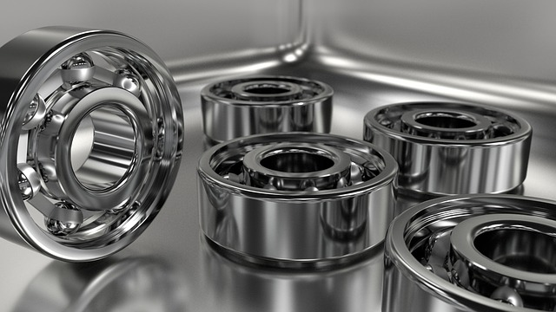
Figure 1: Csapágy [3]
Bullet list text style: List Paragraph.
Example bullet list:
- first list item
- second list item
- third list item
- fourth list item

Equations must be created with the equation editor.

Summary

List of References
This page must contain the bibliography. Individual references must be indicated with serial numbers in square brackets (if square bracket citations were also used in the text; otherwise, simple numbering), with clear correspondence to the relevant in-text citations (text style: Normal).
Example
- Osyczka A., Montusiewicz J. (1992) Modelling and optimization of machine tool spindle systems with hydrostatic bearings = Hidrosztatikus szerszámgép főorsó csapágyak modellezése és optimálása, Gép. 44(9-10) pp. 87-91.
- Vörös I. (1977) Gépelemek, Budapest, Tankönyvkiadó Vállalat. ISBN 963 17 2468 9
- Barótfi I.(2000) A napenergia hasznosítása, In: Barótfi I. (szerk.): Környezettechnika, Budapest, Mezőgazda.pp. 32–70. ISBN 963 286 009 8
- Kovács P. (2010) Finn nyomokon, avagy tradíció a finn építészetben. In: Építészfórum {online} http://epiteszforum.hu/node/17575 (Letöltés időpontja: 2011.02.16.11óra 47 perc)
- http://epiteszforum.hu/node/17575 (Letöltés időpontja: 2011.02.16.11óra 47 perc)
- XY cég belső vállalati anyag.

Appendices
Supplementary, illustrative materials that complement the thesis and show additional details are attached in the order of references in the text. Only appendices mentioned in the text should be included, and their extent should be moderate.

