Thesis

Stu Dent
2016.

University of Debrecen, Faculty of Engineering
Mechatronics Engineering (BSc)

Stu Dent
THE TOPIC OF THE THESIS

Supervisor: Tutor
External consultant: Consultant engineer

Head of Department: Géza Husi Ph.D. habil., associate professor

2016

Thesis task announcement (original, signed by the head of department)
Thesis Evaluation Sheet (signed by the supervisor and the head of department).

Plagiarism statement
I, the undersigned Stu Dent (Neptun code: ABCDEFG) by signing the present statement declare that the thesis entitled

TITLE OF THESIS
- hereinafter called thesis - is my independent work. In the course of making the thesis I conformed to the rules of Act No. LXXVI of 1999 on Copyright, and the regulations of the University of Debrecen regarding the principles of making a thesis, particularly in respect of the references and citations .
I declare moreover that in the course of making the thesis, concerning the independent work I did not mislead my supervisor. I did not make use of any forbidden support, and I did not submit the work as a thesis in any other educational institution previously.
By signing the present statement I take notice of the fact that the University of Debrecen has the right to deny the acceptance of the thesis and to take disciplinary action against me if it is demonstrably not my intellectual creation, if any infringement of copyright falls under suspicion, or I have already submitted the thesis to another educational institution.
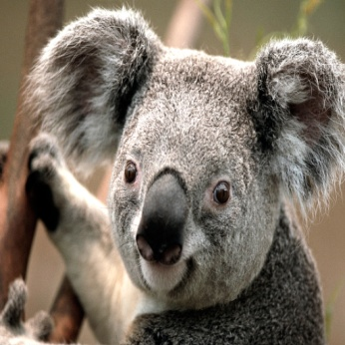
The denial of the acceptance of the thesis and the disciplinary procedure do not affect other legal consequences (Civil Law, Law of Petty Offence, Criminal Law) caused by the infringement of copyright.

signature
Stu Dent
day, month, year, Debrecen

Table of contents
(unnumbered)

Table of contents
Plagiarism statement 6
Table of contents 7
Summary in hungarian 8
Summaryin English 9
Intruduction 10
1. Background 11
2. Main chapter 12
2.1. The length of the thesis 12
2.2. Page format 12
2.3. Titles, subtitles 12
2.3.1. Third-level title sample 12
2.4. Symbols, Equations, Figures 12
2.4.1. Formulas 13
2.4.2. Mathematical variables 13
2.4.3. Figures captioning 13
2.4.4. Tables 15
2.4.5. Units 15
2.4.6. Abbreviations 15
2.4.7. Commercial products 15
2.4.8. Photoes 15
2.4.9. Graphs 15
3. Summary 16
4. References 17
Appendix 18

Summary in hungarian
(sorszámozatlan)
(magyarul) A tartalmi kivonatnak a dolgozat elolvasása nélkül, önmagában is teljes egészet alkotó írásműnek kell lennie, vázlatosan megírva.

Summary in English
(unnumbered)
The abstract without reading the whole paper must be a clear specification.

Introduction
(unnumbered)
Introduction of the thesis in one page. The introduction should contain the following details.
The student where met with the featured topic, what is the problem and how it is related to other topics, why he choose this topic, what is the purpose of the thesis, what he wants to achieve with it and how.

Background
(Literature review of similar works), the conclusion drawn from them. The literary description should be carried out with a critical approach.

Summary of the literature at least in 10 pages. The literary summary should include minimum 10 specialized books, articles and conference articles. The literary summary can be up to 1/3 of Internet resources. (The access databases of publications from the university networked computers: IEEExplore, eisz, Scopus.)

Main chapter
The title of this chapter is optional.
Here you need present the work, plans, detailed descriptions of the solved problems, evaluation of the chosen solutions of the option carried out.
  - The length of the thesis
(Counted from cover and not included the appendix) approximately 50 pages (1,5 distance), use 60-70 keystroke in a line to save the aesthetic appearance. The minimum scope is 35 pages, the maximum is 90 pages.The thesis should carefully pay attention to the grammar and to the ornate stlye.

Page format
Font:Cambria, normal, size 12, 1,5 distance.

Titles, subtitles
Divide your thesis to main and sub-chapters, and use paragraphs within it. The numbering of the chapters follow the decimal system. The first rule for titles that is always positioned in the left margin, be bold and capital letters. If the title in on the top, left two empty lines before and after the title.
Formatting the titles like in the 2. Main chapter.
Second level titles like in the 2.3 Titles, Subtitles.
Third level subtitles: as 2.3.1 Third-level title sample

Third-level title sample
Paragraphs: In the text there are no paragraphs, each line on the left margin should begin. The format of the lines is justified.

Symbols, Equations, Figures
Use the symbols from the charset: €, α, ϕ

Formulas
The formulas should be placed in row and centre. The formulas must be equipped with Arabic numbering in brackets (1), which must be adjusted to the right page margin. In the text the mathematical variables, for example x, y should be in italics. Long equations should be written in two rows.

Mathematical variables
Font: Cambria Math, italic, 12, simple distance, at the end of the line number the marked formula:
$f\left(x\right)=a_{0}+\sum_{n=1}^{∞}{\left(a_{n}\cos{\frac{nπx}{L}}+b_{n}\sin{\frac{nπx}{L}}\right)}$ (1.)
$x=\frac{-b±\sqrt{b^{2}-4ac}}{2a}$ (2.)

Figures captioning
The numbering should be continuous. To each figure must be have a caption which cannot be wider than the figure itself. The figures have to make on PC. Write the figure captions under the pictures, in case of tables write above them. Proposed figures made of other documents or applications as images insert in the thesis, hence the figure dod not “fall apart”.
The inscriptions on the figures must be readable.
Figures: numbered on the bottom centre Cambria, normal, size 10:
1. Fig. Building mechatronical research centre
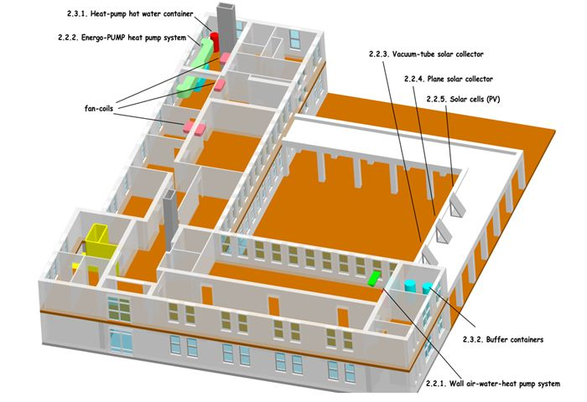

Tables
The tables should be independent from the text, the numbering should be ongoing.Each column must be include well defined symbols and units.
Numbered on the top right Cambria, normal, size 10
1. TableEmpty tble template
ω (angular speed)
[1/s or s⁻¹]

Units
Comply with the International System of Units.

Abbreviations
Avoid the abbreviation of the words, bearing in mind the possible difficulities of interpretation to the reader.At the first time of using an acronym write the whole version. For example Low Pass Filter (LPF).

Commercial products
Avoid the trade products manufacturer’s name, unless it is unavoidable.

Photoes
Both black and white and color pictures allowed, but must be identical contrast.

Graphs
The ordinate, the abscissa explanation, measurement units and other required labels should be provided.

Summary
A summary should be of the main results. If possible, give guidance to the next research steps.

References
At the end of the thesis a numbered bibliography should be placed. Use single spacing and left one empty line between titles. The format is the next: Name of the author(s): Title, name of the journal title, year of publication, number of pages. Just the overall format will be accepted!
Other resources must be marked to make them easy to identify. Pay attention to the Internet links! After all Internet’s data should be placed the URL’s exact date, since the contents of the web pages can be change.
Setting the IEEE Word automatically creates a list of good literature!
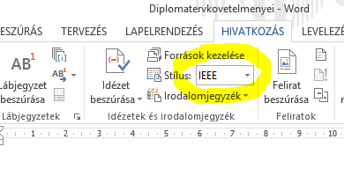

Appendix
(unnumbered) Any detailed calculations, data sheet sources. In the CD/DVD attachment places the full paper and all the necessary attachments, resources and documentation.
Only those documents can be put in the appendix which the study refers to or necessary for understanding.

